

Job Description

Street Presence Coordinator


Vennture – formerly Hereford City Mission founded by John Venn in 1856

www.vennture.org.uk - enquiries@vennture.org.uk - 0330 20 20 730
Vennture, 26 Vicarage Road, HR1 2QN
A registered charity No 1156851 and company limited by guarantee No 8803798.

About Vennture
We’re a local, independent charity supporting families and individuals in Herefordshire with aspirations to grow our mission elsewhere. Whilst our roots are Christian, our paid team and volunteers, like the people we help, may be of any faith, or no faith. It means that you’ll see we take a Christian ‘can-care’ approach to how we treat people.
We are community-minded. Our founder was a free-think leader of his day pioneering new ways to address problems experienced by the people of Herefordshire. A century later, we’re still working smartly to spot, and then meet, the particular needs of our rural county. We support the businesses, organisations and agencies we work with to adapt and flex in order to achieve this too.
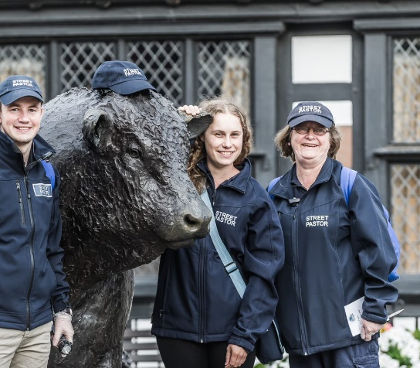
Vennture people come in many guises. You may see our volunteer street pastors in blue coats liaising with police and doormen on a Saturday night or our sixth form and student volunteers who run our night-time safe space or meet our daytime, red coated volunteers providing a daytime reassuring presence on the streets – helping people who may be lonely, lost or unwell. There are also our Link Worker who mentor individuals and families. All our people are recruited through safer recruitment and trained in the very best ways to work safely and safeguard the most vulnerable.

Here to help people in difficulty. You’ll find us non-judgemental and caring. We offer time to listen, and to work out, what changes a person wants to make, so that life is better for them in the ways they want. Those changes may be a stronger family life, improved school attendance, or more stable housing and finances. Together we put people centred plans in place and help people to help themselves through relational mentoring. This could include supporting someone to deal with statutory services, sharing new ways of parenting, or helping with finances or addiction. Most importantly, we’re there through the ups and the downs, journeying together to reach their goals. We’re in touch weekly, face to face, and over the phone, typically giving six months of support, but it can be longer.

Vennture’s mission is to ‘Love People Better’. Put simply we want to equip people to help people. In all our programmes we develop in people three things: the awareness to come alongside others; the presence to travel with them through thick and thin and a sense of ownership that allows them to stick with people whatever happens. Like John and Emelia Venn, we want to show The Power of Jesus Love by living out the values that they both held as precious. It is important that in applying for this post you appreciate that these values shape everything we do. An essential requirement of this role is that you demonstrate respect for the values in your professional and personal life.

Vennture’s programmes
 | Street Pastors – Have a good time, come home safe  Street Pastors engage with people on the streets to care for them, listen to them and help them. They work together with partners in the night-time economy to make communities safer.
 | Lean on Me – Care more, respond faster  This is a safe caring space where people can recover if they have become intoxicated while out on Saturday night. It only opens to people referred to it for the special care it offers and provides valuable support to the Street Pastor teams.
   | Ambassadors – Love our city better  Teams volunteer in Hereford to keep people safe, support the vulnerable and provide first aid. Their mission is to make Hereford an even better place to shop, visit and work.  Families - Helping families to help themselves  The Families team work with parents and children by listening to them in a non-judgemental way and helping them gain the support they need to make changes, find solutions to their challenges and bring new hope into their lives.
 | Fresh Start – Helping people support themselves  The Fresh Start programme supports individuals through weekly mentoring. The focus is on supporting them overcome barriers to having a safe place they can call their own and the finances to pay for it, purposeful activity and positive relationships in their lives.

Venn values
Faith: We live in the light of love and recognise that love can change everything: – loving God and loving others as we love ourselves. We value each individual as special; each has a unique mix of God given gifts, talents and experiences. We work with, serve and relate to all people.
Love: We recognise family is an answer no matter how messy it gets. We encourage individuals to be and act as servant leaders in their lives, family, work and community. We never give up on people encouraging them to take the steps that can lead to big changes. We accept everyone as we find them and without conditions; we encourage people to live a life rooted in love.

Endeavour: We except we don’t have all the answers and in sharing in each person’s journey we are willing to share the changes we are making in our own lives. We respect, nurture and promote a strong work ethic to build everyone’s esteem, resilience and resourcefulness. We encourage enterprise to create more to invest in helping individuals to take responsibility for their future.

Position Outline
Employer: Vennture
Job title: Street Presence Coordinator
Reports to: Chief Operating Officer
Direct Reports: All teams that deliver Vennture’s Street Presence, Employees and volunteers
Job description: See following pages

Start date: TBC
Contract Type: Permanent
Notice period: The appointment is subject to the satisfactory completion of a six-month probationary period, thereafter one calendar months’ notice on either side.
Hours per week: Full Time Hours of 37.5 per week as required, will be worked flexibly as it will include some weekend and evening work

Location: Vennture Offices, 26 Vicarage Road, Hereford HR1 2QN

Gross salary: £24,447 - £26,484 dependent on experience

Holidays: 240 hours including Bank Holidays
ALL holidays to be agreed in advance in accordance with the Employee Leave Guide
Travel: Driver with access to a car and a willingness to travel; the employee is responsible for insuring their vehicle for business use.
Benefits: Travel Expenses
NEST Pension Scheme

Specific areas of responsibility
Promote Vennture’s Mission – bring practical meaning to The Power of Jesus’ Love
- Make Jesus a natural part of every conversation internally and externally
- Model Christian faith and values in public and within Vennture
- Facilitate prayer meetings, team events, and pastoral support for volunteers
- Liaise with church leaders and congregations to encourage volunteer recruitment and engagement
Administration & Coordination
- Manage volunteer onboarding, maintain accurate records, and schedule rotas for Street Presence teams
- Provide administrative support for patrols, events, and training sessions
- Prepare newsletters, reports, and communications for volunteers and church partners
- Analyse data and create reports on Street Presence activities and impact
- Ensure compliance with Safer Recruiting protocols and maintain up-to-date documentation
Street Patrols
- Participate in regular patrols as part of the Street Presence team, supporting vulnerable individuals and engaging with the public
- Work alongside local agencies, including police and community partners, to ensure the safety and wellbeing of those encountered
- Provide practical support, signposting, and care during patrols
Volunteer Support
- Encourage, support, and communicate with volunteers, including facilitating socials and prayer evenings
- Assist with recruitment and induction of new volunteers, especially from church communities, sixth formers, and students
- A committed Christian, able to demonstrate faith in professional and personal life (Faith-based GOR applies under the Equality Act 2010)
- Strong administrative and organisational skills
- Excellent written and verbal communication
- Ability to work independently and as part of a team
- Willingness to participate in street patrols, including some evenings and weekends
- IT literate (Microsoft Office, email, data management)
- Compassionate, resilient, and authentic, with a sense of vocation for serving others
Desirable
- Experience in church-based outreach or community work
- Understanding of issues affecting vulnerable people in the night-time economy
- Previous experience supporting or coordinating volunteers

Faith-Based Genuine Occupational Requirement
This post is subject to a Genuine Occupational Requirement under the Equality Act 2010 that the post-holder is a practising Christian, due to the nature of the role and Vennture’s mission.

